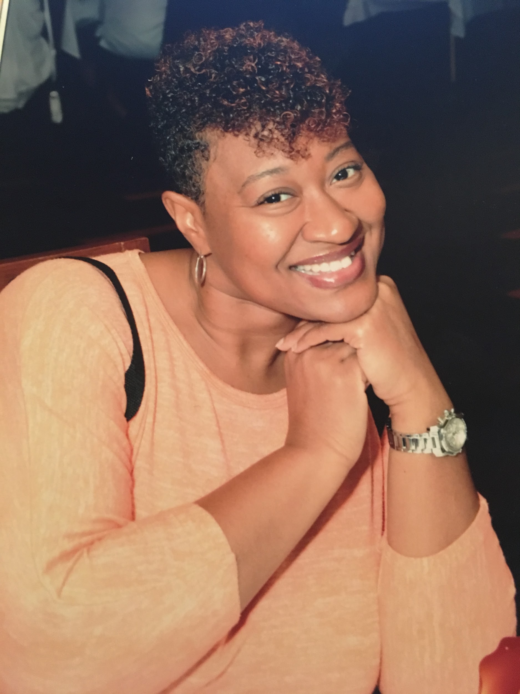
Yakata Nichols, B.S., NIC

Yakata Nichols is a passionate CODA with 15 years of interpreting experience. She is Nationally Certified through RID (NIC) and currently is serving as President of NAOBI- Detroit. Her previous positions include two consecutive terms as Vice President of NAOBI-Detroit, Professional Development Chair for NAOBI-Detroit and Member -at -Large, MAL for MIRID.

Yakata holds a Bachelor of Science in Business and Marketing & Business Administration from University of Phoenix. She primarily works as a medical and mental health interpreter in the Detroit Metro Area, her interpreting background includes interpreting for programs such as: Massage therapy, Medical Assistant, Direct Care Aide, Medical Billing and Coding, Phlebotomy, and fourth- year Medical Student intern doing rotations. Additionally, she has extensive training in medical interpreting; attending various conferences and trainings from the National Healthcare Symposiums, MHIT- Mental Health Interpreter Training, International Medical Interpreter Association Conference.

Yakata is currently a candidate for her Master in Science in Healthcare Interpretation from RIT. Her interests include community involvement, leadership, and traveling.

